# STOCK PRICE PREDICTION AND ANALYSIS

***Synopsis submitted to***

***Guru Jambheshwar University of Science and Technology,***

***Hisar for the partial award of the degree***

***of***

## Master of Computer Applications

**Manjeet**

(210010120023)

## & Monika

(210010120025)

***by***

## Supervisor Name: Dr. Om Prakash

**Sangwan**

(Professor)

## Dr. Sunil Kaushik

(Assistant Professor)



## Department of Computer Science & Engineering

**GURU JAMBHESHWAR UNIVERSITY OF SCIENCE ANDTECHNOLOGY, HISAR**

**May 2023**

# Index

|  |  |  |
| --- | --- | --- |
| Sr. No. | Content | Page No. |
| 1. | Introduction | 3-4 |
| 2. | Literature Review | 5-6 |
| 3. | Problem Statement | 7 |
| 4. | Objectives | 8 |
| 5. | Methodology and tools | 9-10 |
| 6. | References | 11-12 |

**Introduction**

The stock market is a complex system that is influenced by a variety of factors, including market trends, company financials, sentiment in the news, and economic trends. For investors and traders to make essential decisions about buying or selling stocks, it is essential to predict stock prices accurately and analyse market trends. For investors and traders to make essential decisions about buying or selling stocks is essential to predict stock prices accurately and check market trends.

The goal of the project "Stock Price Prediction and Analysis" is to develop a machine learning-based approach for predicting stock prices and examine market trends. The focus of the project is collecting historical stock market data, pre-processing and cleaning the data, and applying feature engineering techniques to extract relevant features for stock price prediction. The project then develops a predictive model using various machine learning algorithms such as linear regression, random forest, and neural networks. The model's accuracy is evaluated using metrics such as RMSE and MAE.

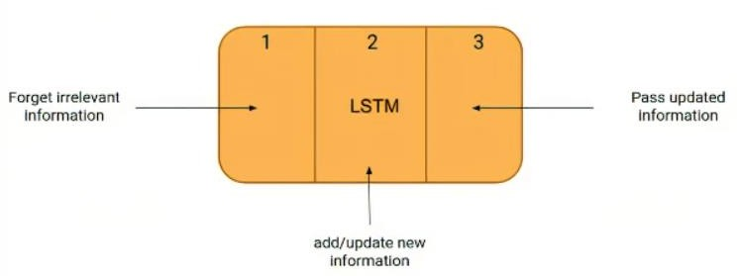

FIGURE:1 (LSTM)

In addition to predicting stock prices, the project includes data visualization and analysis of various factors that may influence stock prices, such as economic indicators and news sentiment. This analysis can provide insights into market trends and help investors and analysts make informed decisions.

The project's results can be used to help investors and traders make better decisions about buying or selling stocks, and analysts can use the findings to gain insights into market trends and factors that affect stock prices. In summary, the "Stock Price Prediction and Analysis" project offers a valuable tool for predicting stock prices and analyzing market trends, providing a significant advantage for investors and traders in the stock market.

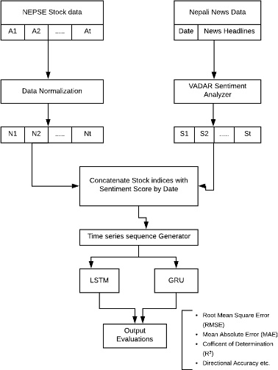

FIGURE:2 (TIME SERIES ANALYSIS)

# Literature Review

“Stock Price Prediction using Machine Learning” by Anshuman Behera , Ayes Chinmay . [1] Using machine learning to anticipate stock prices may be expensive, and most small investors cannot afford to pay that price. This is the primary motivation for large brokerage firms to promote algorithmic trading. Algorithm trading is a more advanced type of machine trading in which a machine uses the machine learning technique to automate the buy and sale of shares in bulk. This lowers the operating costs of algorithm trading, making it more accessible to the public. Here, algorithm trading offers advantages such as lower costs, less reliance on human emotions, and more accuracy. [7] The stock market is a gamble for most individuals since they do not follow the basic investment idea of studying the company's fundamentals and financial profit and loss statements. Because India is one of the world's fastest growing economies, the government encourages citizens to invest in the stock market. These investments enable the corporation to expand its operations and contribute to the country's economic growth.

“Stock Market Prediction Model Based on LSTM Deep Learning: The Case of Top Corporate Company in China” by Yaojun Zhang, Gilbert M. Tumibay [2] This paper presents a stock price prediction method based on LSTM neural network. This method fully considers the influence of the long series characteristics of the data and extracts the key feature information in the previous article to predict the closing price. “By applying it to the prediction of stock data of a well-known domestic enterprise, and comparing it with RNN model, the experimental results show that LSTM model has higher accuracy in stock data prediction.”. Model used in this paper shows definite result, “the input features of the model are all selected daily stock market data, and the selected features have certain limitations. Subsequent research can add macro economy, investor sentiment and other technical indicators as input features to test the prediction effect of the model”.

“Stock Market Prediction Using Deep Learning LSTM Model”, by Shruti Goswami, Sonal Yadav, [3] In this paper, they predicted stock price. Here, they used HCL Tech, a NSE Nifty 50 stock and they have studied the implication of the epochs as well as the Batch Size. Here 2 batch sizes, batch-size=30 and batch-size=50 are taken. For both the

cases 4 different epochs are used. And percentage error (MAPE) was calculated in all the cases. And it is shown that with batch-size=50 and epochs=100, the model worked best. Models different performance depends upon the batch size and epochs.

“Stacked LSTM a Deep Learning model to predict Stock market” by Bandi Jaswanth, Jitendra Kaushik, [4] They conclude “The first model (using activation function. Mention the name of activation function) has better root mean square error for test and train data in both the models. The training RMSE for model is 114 and testing RMSE is

264. For the second model, training RMSE for model is 112 and testing RMSE is 257.”.

“Stock Market Prediction Using RNN LSTM” by Priyanka Srivastava, P K Mishra, [5]. In their project they find that the stock market system forecast might be further enhanced and innovated utilizing much more data than the present one. It would help to improve the accuracy of their prediction models. RMSE and Plot Trends show that the LSTM model is exactly accurate in forecasting stock markets between all algorithms.

“Prediction of Trends in Stock Market using Moving Averages and Machine Learning” by Shoban Dinesh, Nithin Rao R, S P Anusha, Samhitha R, [6]. This paper proposes the use of Machine learning on technical indicators to overcome the disadvantages of the indicator-based trading strategy. This method identifies the latency of moving averages as a disadvantage and proposes an algorithm to overcome the drawback. They finds the conclusion “The proposed model was developed with 79.7% accuracy on the IBM stock, 80.4% accuracy on the GOOGL stock and 80.5% accuracy on the AAPL stock.”. The model predicts the bearish and bullish crossover ahead in time to reduce the latency and to predict the reversal of trend. [10] From the results obtained, it is evident that the proposed model not only overcomes the disadvantage of the moving average but also assists the trader to increase the profits.

# PROBLEM STATEMENT

The stock market is a complex and uncertain system that can be influenced by various factors such as economic indicators, news sentiment, and company financials. Predicting stock prices and analyzing market trends is critical for investors and traders to make informed decisions about buying or selling stocks. However, accurate stock market prediction and analysis remain a challenging problem due to the complexity and volatility of the stock market.

Traditional methods of stock market prediction and analysis rely on human intuition, experience, and financial knowledge. However, these methods are often subjective, time-consuming, and prone to error. Hence, there is a need for an automated, data-driven approach that can provide accurate and reliable stock market predictions and analysis.

Machine learning-based approaches can offer a solution to this problem by utilizing historical stock market data and other relevant features to develop predictive models that can accurately forecast stock prices and analyze market trends. Therefore, the problem statement for the "Stock Price Prediction and Analysis" project is to develop a machine learning-based approach for predicting stock prices and analyzing market trends accurately. The project aims to create a predictive model that can help investors and traders make informed decisions about buying or selling stocks and provide valuable insights for analysts to gain a better understanding of the stock market's behavior.

# Objectives

The main objective of the "Stock Price Prediction and Analysis" project is to develop a machine learning-based approach for accurately predicting stock prices and analyzing market trends. This objective involves several sub-objectives that need to be achieved to attain the overall goal of the project.

* The first sub-objective is to collect and preprocess historical stock market data.
* The second sub-objective is to apply feature engineering techniques to extract relevant features from the collected data.
* The third sub-objective is to develop and evaluate a predictive model using various machine learning models.

# Methodology and tools to be used

The methodology and tools used for stock market prediction and analysis may vary depending on the specific requirements and objectives of the project. Here are common methodology and tools that we are using for stock prediction and analytics: -

Data Collection and Preprocessing: The first step in stock market prediction and analysis is to collect historical stock market data and other relevant features such as economic indicators, news sentiment, and company financials. The data needs to be cleaned, processed, and transformed into a format that can be used for predictive modeling and analysis. Tools such as Python editor (Jupyter Notebook) are used for data collection and preprocessing.

Feature Engineering: Feature engineering involves selecting the most significant features that can contribute to accurate stock price prediction and analysis.

Machine Learning Models: Various machine learning models are present. In our project we going to use LSTM models which is used in time series analysis.

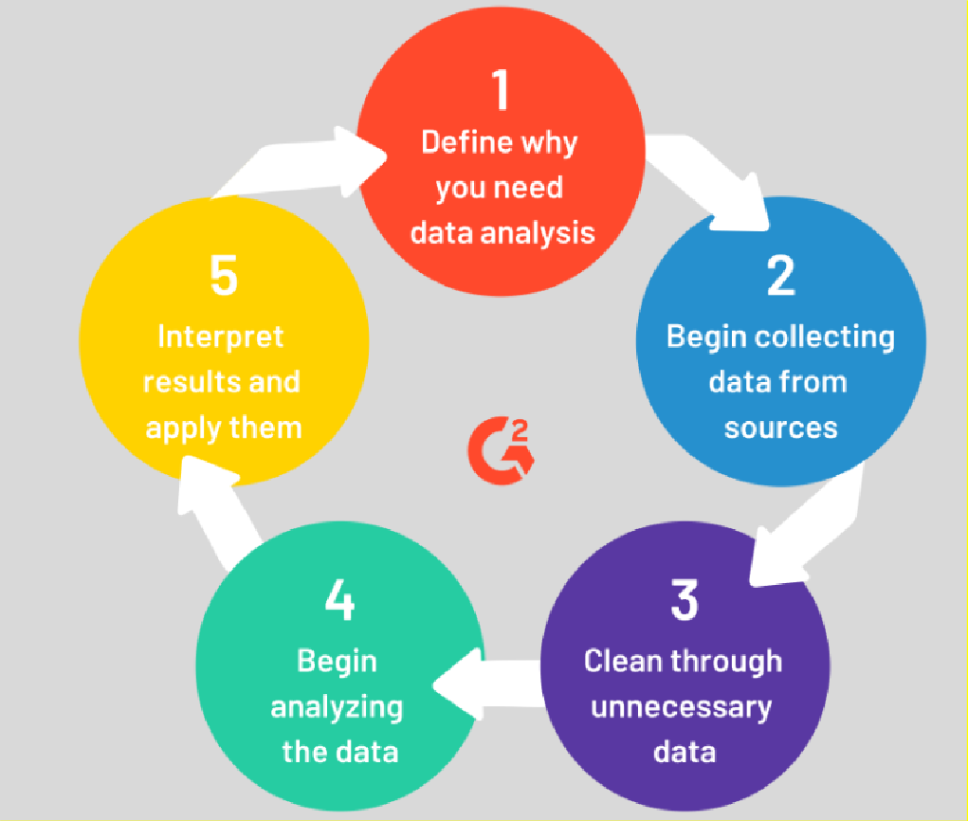

Analysis and Visualization: The analysis and visualization of market trends and the impact of economic events and news sentiment on stock prices are essential for gaining insights into the stock market's behavior.

Evaluation and Reporting: The accuracy of the predictive model needs to be evaluated using metrics such as RMSE. The results of the project need to be presented using

interactive visualizations and reports that can be easily understood by investors, traders, and analysts. Tools such as Jupyter Notebook is a good choice.

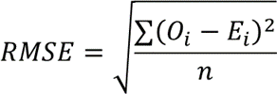Formula for RMSE calculation: -

Where O*i* is the observed values, E*i* are the expected values,

Ʃ is a Greek letter called sigma which represents ‘sum’ and N is the sample size (the number of observations).

The methodology and tools used for stock market prediction and analysis need to be comprehensive, reliable, and accurate, providing a valuable tool for investors, traders, and analysts to make informed decisions and gain insights into market trends.

## Software Requirement: -

* Jupyter Notebook
* Python Libraires: - pandas, NumPy, seaborn, matplotlib
* Database Source: - Yahoo finance

## Hardware Requirement: -

* Operating System: - Windows 10 or above.
* Ram: - 8 GB
* Storage: - 256GB(SSD)

# References/Bibliography

1. Anshuman Behera and Ayes Chinmay, “Stock Price Prediction using Machine Learning”, 2022 International Conference on Machine Learning, Computer Systems and Security (MLCSS).
2. Yaojun Zhang, Gilbert M. Tumibay, “Stock Market Prediction Model Based on LSTM Deep Learning: The Case of Top Corporate Company in China”, 2022 4th International Conference on Artificial Intelligence and Advanced Manufacturing (AIAM).
3. Shruti Goswami, Sonal Yadav, “Stock Market Prediction Using Deep Learning LSTM Model”, 2021 International Conference on Smart Generation Computing, Communication on and Networking (SMART GENCON) Pune, India. Oct 29-30, 2021.
4. Bandi Jaswanth, Jitendra Kaushik, “Stacked LSTM a Deep Learning model to Predict Stock market”, 2022 4th International Conference on Advances in Computing Communication Control and Networking (ICAC3N).
5. Priyanka Srivastava, P K Mishra, “Stock Market Prediction Using RNN LSTM”, 2021 2nd Global Conference for Advancement in Technology (GCAT) Bangalore, India. Oct 1-3, 2021.
6. Shoban Dinesh, Nithin Rao R, S P Anusha, Samhitha R, “Prediction of Trends in Stock Market using Moving Averages and Machine Learning”, 2021 6th Inter - national Conference for Convergence in Technology (I2CT) Pune, India. Apr 02-04, 2021.
7. Ishita Parmar, Navanshu Agarwal, Sheirsh Saxena, Ridam Arora, Shikhin Gupta, Himanshu Dhiman, Lokesh Chouhan, “Stock Market Prediction Using Machine Communication(ICSCCC).
8. Xu Zhang, Li Zhang, Lingjun Xu, Yue Jiang, “Research on Influential Factors in Stock Market Prediction with LSTM”, 2022 the 7th International Conference on Big Data Analytics (ICBDA).
9. Khurum Iqbal, Ali Hassan, Syed Shah Mir Ul Hassan, Shuaib Iqbal, Faheem Aslam, Khurrum S Mughal, “Forecasting Stock Market Using Machine Learning Approach Encoder-Decoder ConvLSTM”, 2021 International Conference on Frontiers of Information Technology (FIT).
10. Pushpendra Singh Sisodia, Anish Gupta, Yogesh Kumar, Gaurav Kumar Ameta,

“Stock Market Analysis and Prediction for Nifty50 using LSTM Deep Learning Approach”, 2022 2nd International Conference on Innovative Practices in Technology and Management (ICIPTM).

1. Nirupama Parida, Bunil Kumar Balabantaray, Rajashree Nayak, Jitendra Kumar Rout, “A Deep Learning based Approach to Stock Market Price Prediction using Technical indicators”, 2023 International Conference on Advances in Intelligent Computing and Applications (AICAPS).